**Ottery St Mary Short Mat Bowls Club**

**Looking for something new to try?**

Monday Evening 7pm – 9:30pm

Wednesday Morning 09:45 – 11:45am

We are a friendly group who welcome new members (18+)

The first three visits are free, so come and have a go!!

We provide everything you need to play.

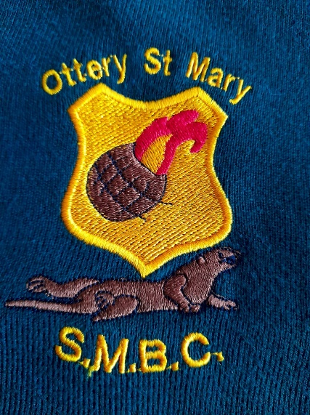Open all year round at the Institute.

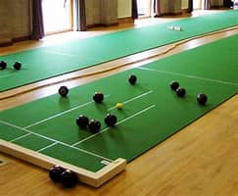

Call, message or just turn up to find out more:

Kathryn: 07507 308068 or Tony: 07876 064094

*otterystmarysmbc@gmail.com*