Report from Cllr Jess Bailey
Devon County Councillor
July 2021

Ottery Community Volunteers

Well done to the Ottery Community Volunteers who organised an excellent clean up in Ottery this weekend. It was great to see so many people clearing up all around town. I really enjoyed litter picking in Winters Lane, Longdogs Lane, Higher Spring Gardens and Yonder Street. Thank you to the organisers and I look forward to the next community clean up.

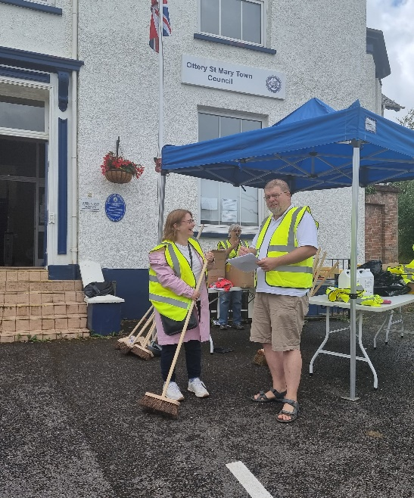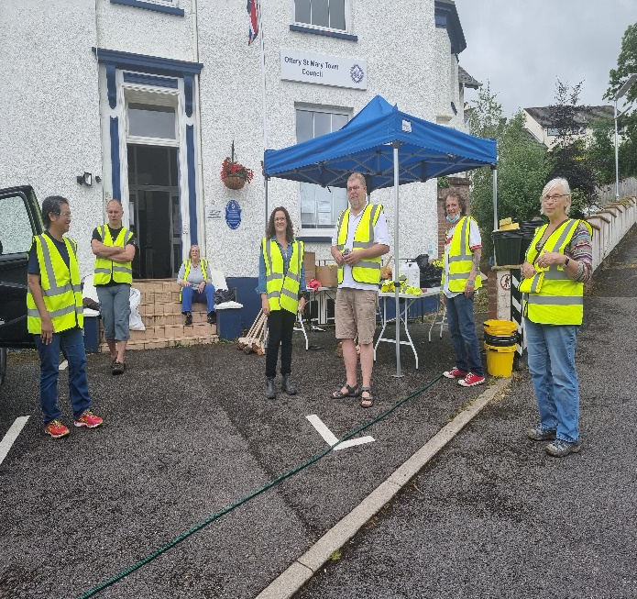

Straitgate Quarry

EDDC, in its capacity as consultee on the Straitgate Quarry application has submitted an objection to Devon County Council. As the EDDC West Hill ward member I participated in the delegated planning meeting and supported the proposed position taken by EDDC. The objection arises from the concern that EDDC has in respect of the updated transport assessment submitted by Aggregate Industries.

EDDC feel that this does not adequately address the issue of increased cattle crossings which will be caused by the loss of cattle grazing land north of the B3174. EDDC believe that these crossings will have a “significant adverse impact on the free flow of traffic into and out of Ottery St Mary, to the detriment of the economy, environment and the wellbeing of the area and its inhabitants, as well as the safety of road users”. EDDC have made it very clear that although they had recently granted recently granted consent to the crossing in a different location this did not authorise an increase in the volume of crossings (I also objected strongly to this application submitted by Aggregate Industries to EDDC but it was regrettably approved).

I very much support the position taken by EDDC in submitting an objection to DCC. I have serious concerns about the crossings – as well as many other aspects – of this application. Jess Bailey – Independent Councillor for West Hill and Ayleseare (home.blog).

Flooding/water issues

Emergency Plan
I am concerned about the flood risk situation in the parish, in particular at Tipton St John, and am keen to ensure that there is an appropriate community flood plan in place for Tipton St John given its established difficulties with flooding which is supported by the ‘early warning’ system telemetry gauge at the Metcombe Brook.

As you know, the gauge provides a warning to the school and the contract for the maintenance of the gauge is due to expire this month. This asset was transferred to the Town Council in 2017 but Devon County Council have continued to pay for it, but are not able to continue doing so. The annual cost of the gauge is around £500 and I would like to offer to pay half of these to ensure that the warnings still come through.

There are also two rain water gauges in Ottery St Mary, which provide notifications, but I am not sure who these are sent through to within the town council and again these contracts are due to expire. Again, the costs have been met by DCC previously but are not able to continue doing so.
I have been sent the Emergency Plan (2015) prepared by Ottery St Mary town council but I think it is very important that there is an up to date plan, particular with reference to flooding issues in Tipton St John. Devon Communities Together have contacted me and would be happy to support this process. Particularly given increasingly unpredictable weather patterns as a result of climate change it is more important than ever to have a flood plan in place.

I have previously circulated a template emergency plan, which includes at Annex F, a brief community flood plan.

Ridgeway/Washfield
DCC were alerted late last year to high water levels and potential flood risk within the open section of the leat at Washbrook View and separately a garden flooding downstream on Ridgeway related to a culverted section of the leat.
Surveys have been undertaken and the culvert has been jetted. This cleared debris including twigs that had built up within the culvert, which enabled the water levels at the open section at Washbrook View to reduce. DCC officers have had discussions with the landowner (EDDC) at the open section of the leat on Washbrook View about measures that could be put in place to reduce the chances of this reoccurring, this could include a finer screen on the inlet to the culvert which will require more regular maintenance. DCC is still awaiting the survey recommendations for this section before any potential works can be initiated.
DCC officers have been liaising with residents of Ridgeway in relation to the culverted section of the leat, as they are the riparian owners for the sections of the leat within their property boundary. Again they are waiting for more detailed comments from the drainage company they contracted to do the survey.
Cllr Faithful has raised some issues last week with DCC officers regarding the state of the leat across its entire length. DCC are happy to work with local Cllrs to help address any matters relating to flood risk management. I understand some of the issues relate to drain covers and overgrown vegetation on the road which will need to be reported to Highways through their online portal.
I also understand that there may have been discussions about the drying up of the leat and EDDC may have been involved in these discussions Please let me know if you would like DCC to be involved.
Otter Mill
I understand that residents may have previously contacted the town council in relation to the condition of the wall adjacent to the footpath and I have now been contacted. I am in touch with DCC flood officers about this issue and they have in turn communicated with the Environment Agency.
Drainage at Alfington
I met with Mike Brown , neighbourhood highways officer, and residents from Alfington to investigate concerns that residents have about surface water on the roads. It was agreed that the ditch would be cleared (as part of the main programme of ditch cleaning) and where there is currently a gap the bank would be built up. Once this had been done the pipe which passes into the field and then under the track would be jetted.
Resurfacing works
I was disappointed to learn from the highways manager that the resurfacing works on Yonder Street and Jesu Street have not been scheduled until 21st September. This is something that I am following up and am pressing for an earlier start date. Although I am pleased that the worst potholes at Bridgefield/Slade Road have been filled I am frustrated that it is taking so long for the resurfacing works to be carried out. I understand from the highways officers that there are issues with timetabling the resurfacing works but I do not believe that it is acceptable to wait until the second half of September.
Preparation of the Local Plan

The interactive plan showing all the sites that landowners have put forward under the local plan is now live on EDDC’s website. Housing and Economic Land Availability Assessment - East Devon. There are 17 sites that have been put forward in the Ottery St Mary ward.

Devon County Council as highways and education authority will be consulted as part of this HELAA process whereby the sites are considered before their possible inclusion in the Local Plan. DCC highways department are unable to commit to a particular date to review the sites, so EDDC’s approach will be to consider the largest sites first.

As part of the consideration of whether the sites are potentially “achievable”, the sites will be looked at by the HELAA panel. EDDC officers advised that “Membership of the Panel is representative of a broad cross section of the housing and economic development sectors, including house builders (volume and smaller scale schemes) social landlords, local property agents, and other related professions, local community representatives and other agencies”. I asked for details of details of membership of the Panel but officers were reluctant to provide this information. It is totally unacceptable for the panel to be kept secret.

